

FortnaPlus Control
Request Host Status
Document Revision: 1.1
Date: 14-Jan-2021

Revision | Date | Author | Revision Summary
1.0 | 14-Jun-2011 | P Rotter | New document
1.1 | 15-Nov-2012 | P Rotter | On-screen button information added
1.2 | 24-Apr-2013 | B C Conklin | Added ErrorsRecord column information
1.3 | 25-Apr-2013 | B C Conklin | Added columns to latch the error and clear it
1.4 | 14-Jan-2021 | T R Kremser | Updates and general refresh. Combine all RHS-related documents.

Table of Contents
1. Glossary of Terms 4
2. The SrtHrtBeat Table 4
3. Request Host Status Message 6
4. RHS Communication Flow 6
5. RHS Message Format 7
6. Configuration 8
7. RHS Communication Verification – CommCore 9
8. RHS Communication Verification – Simulation 9
9. RHS Error On-Screen Status 10
9.1. Configuration – Memory Bits 10
9.2. Configuration – On-Screen Part 11
9.3. Configuration – Errors Table 11
9.4. Configuration – SrtHrtBeat Table 11
9.5. RHS Processing Explanation 12
9.6. On-Screen Status Examples 12

Confidential/Proprietary Statement
This document contains trade secrets and information that is considered confidential and proprietary to Fortna, Inc. It may not be duplicated, used, or disclosed outside the original recipient organization, and it may not be duplicated, in whole or in part, for any purpose other than to evaluate this document. Fortna Material Handling reserves the right to modify this document as necessary to reflect any terms and conditions negotiated and included as part of a subsequent contract or purchase order.

Glossary of Terms
FPC – FortnaPlus Control, also known as “Level 1”, is the software that runs in the QNX real-time operating system and controls the conveyor hardware. It interfaces with CommCore, which provides routing information.
CommCore – Also known as “Level 2”, the business logic layer that interfaces to FPC and to the customer’s WCS and the Oracle database. CommCore provides routing information to FPC, and provides divert confirm information to the WCS while storing information about its activities in the Oracle database, among other functions.
WCS – Warehouse Control System. The customer’s order management system.

The SrtHrtBeat Table
The SrtHrtBeat table (Configuration Menu -> Communication Utilities -> COMM HeartBeat) is used to monitor the send queue for any messages that have not been sent in the configured time interval, and to configure RHS messages to be sent to CommCore. These two aspects can be configured independently. An error can be configured to cause the system to stop if communication is interrupted or the message send queue grows too large.
Multiple entries can be configured to monitor multiple communication ports.
When a communication error is detected, it will remain ON until it is manually reset from Maintenance Menu -> Reset Utilities -> Reset Comm Error, even if communication resumes. An input signal (from a button, perhaps) can also be used for the reset.
When used with a Print and Apply line, PrintApplyLine_HostCommFault (Configuration Menu -> PrintApply Utilities -> Printer Apply Line) can be used to select a SrtHrtBeat entry to stop the line when a host error occurs.
SrtHrtBeat Table
Field | Type | Value or Description
Name | String | Enter a unique name
EnableFlag | Y/N | Enter Y to enable processing for this row
Status | String | Updated by the software to indicate the state of this row
AppSorter | PopUp | Select the sorter that is associated with this row, if any. The selection is used by the software to stop the sorter if SrtAppControl_SorterCnvMtr has an IO selected, and StopSorterOnErr or StopSrtOnHostErr are set to Y.
StopSorterOnErr | Y/N | Set to Y to stop the motor defined in SrtAppControl_SorterCnvMtr when an error occurs.
StopSrtOnHostErr | Y/N | Set to Y to stop the motor defined in SrtAppControl_SorterCnvMtr when an error is reported by CommCore.
AutoResetError | Y/N | Set to Y to automatically reset communications errors when they clear. If set to N, the error must be reset manually from Maintenance Menu -> Reset Utilities -> Reset Comm Error, or by selecting a signal in ResetCommErrSig (see below).
ControlMachine | PopUp | Select the machine associated with this row.
MsgMenu | PopUp | Select the table to monitor for queued messages, such as MsgCR1. If this row is to be used for heartbeat (RHS) messages, use the HrtMsgTable field instead.
HrtMsgTable | PopUp | Select the table to use to send heartbeat (RHS) messages, such as MsgGP1. If a heartbeat message is not needed set this column to “N/A”.
HBTimeIntrvl | Int | Enter the number of seconds to wait before checking if the prior message was received. 5 seconds is a good choice.
HBMsgIntrvl | Int | Enter the number of seconds between RHS messages. If set to 0, the system will only monitor the message queue for old messages and no RHS messages will be sent. 20 seconds is a good choice. Heartbeat messages will not be queued if they are unable to be sent.
MsgErrTime | Int | Enter the number of seconds to wait before activating CommErrSignal. For example: If set to 30 seconds, the system will not turn on the error signal until a message is waiting in the send queue for at least 30 seconds. This time is included in the RHS message sErrTime field. CommCore may use this time to determine if host messages are too old.
SendInitMsg | Radio | Select to send an INI message when the system is started.
CommErrSignal | PopUp | Select the error signal to activate when a communications error occurs. For proper operation, a unique communications error signal must be selected for each row in this table.
CommErrACTION | PopUp | Select the action to take when a communications error occurs.
CommErrBIT | Int | Set the bit to use if the enable/disable action is used in the prior column.
CommErrBit | PopUp | Select a memory IO bit to use when a communications error is detected. Use Errors_TrigIO to activate the error.
HostErrSignal | PopUp | Select the error signal to activate when the heartbeat response indicates an error with the Host. For proper operation, a unique host error signal must be selected for each row in this table.
HostErrACTION | PopUp | Select the action to take when a host error occurs.
HostErrBIT | Int | Set the bit to use if the enable/disable action is used in the prior column.
HostErrBit | PopUp | Select a memory IO bit to use when a host error is detected. Use Errors_TrigIO to activate the error.
HostMsg | String | Enter a message that uniquely identifies this RHS message. For example: If CommCore communicates with multiple host systems the message will identify the specific host. This then links the status of that host to a specific Errors table entry triggered by the host response.
ResetCommError | Y/N | Set to Y here to manually reset the Comm Error. If the message queue has cleared, the error will clear.
ResetCommErrSig | PopUp | Select an error signal that can be used to reset the communications error.
ErrorsRecord | PopUp | Select the Errors table entry that will be populated with the “error description” returned from CommCore.
pQtyQueue | Int | Indicates the number of messages currently waiting in the send queue.
pCommAlrmState | Int | Indicates the CommCore interface is in an alarm state.
pHostAlrmState | Int | Indicates the Host interface is in an alarm state.
pLastTime | Time | Indicates the time stamp of the oldest message.
pLastMsgTime | Time | Indicates the time when the last message was sent to CommCore.
pLastDbKey | Int | Used by the software to keep track of the last message that was not sent.
pLastQueTime | Int | Used by the software to calculate the elapsed time to detect when an error occurs.
pErrorFlag | Int | Set by the software to stop the motor in the SrtAppControl record.
pCommAlrmLtch | Int | Set by the software to latch the state of an alarm. Operator input is required to clear the error.
pHostAlrmLtch | Int | Set by the software to latch the state of a host error. Operator input is required to clear the error.

Request Host Status Message
FPC implements the RHS message as a standardized means to monitor the communication path through CommCore to the WCS host via periodic polling.
The message serve as a heartbeat to indicate the connection the CommCore is present, and can also indicate the status of the host message queue.

RHS Communication Flow
FPC initiates RHS messages to CommCore. The response from CommCore confirms CommCore’s presence with a status of OKAY. It can also indicate the connection to the WCS is active, as well. If FPC receives no response, it can be configured to take an action, such as stopping a sorter and raising an error message.
WCS
CommCore
FortnaPlus
RHS

RHS Message Format
The following table shows the content of the RHS message. When the AC receives a RHS message, it will update the SrtHrtBeat table based on the sStatus string received.
Request Host Status Message
Field | Value or Description
Start Character | <STX> (Start of text character)
CmdHdr | “RHS”
Header | “AC1” (FPC AC Name)
Col1 | “iQty”
Dat1 | Quantity of fields (starting with Col1)  This is set to 9 by FPC when the message is generated, though the message actually includes 11 fields. This is probably a bug.
Col2 | “sHostStatus”
Dat2 | Despite being labeled “sHostStatus”, this field does not appear to actually report the host status. It is ignored by the message parsing code.
Col3 | “ ”
Dat3 | This field is apparently not used; could be rented for advertising space
Col4 | “sFunction”
Dat4 | “Read”
Col5 | “sStatus”
Dat5 | This field reports the status of the host. The message is sent from FPC with “Okay”. The response from CommCore will be:  - “OKAY” or “Okay” indicates nominal communication  - Any other string (including empty string) indicates failed communication
Col6 | “sStatusMsg”
Dat6 | This field provides a field for additional status information from CommCore.
Col7 | “sNotUsed”
Dat7 | Not used (then why is it here?)
Col8 | “sHeartBeatTable”
Dat8 | The message table index value of table SrtHrtBeat
Col9 | “sRecordIndx”
Dat9 | The row index value in the SrtHrtBeat table.
Col10 | “sErrTime”
Dat10 | This field contains the value from the MsgErrTime table SrtHrtBeat record. The value may be used by CommCore when evaluating delays from the WCS system. The value is not parsed in the returned message.
Col11 | “HostMsg”
Dat11 | Includes the string from SrtHrtBeat_HostMsg in the outbound message. CommCore could do something with this.
End Character | <ETX> (End of text character)
NOTE: Commcore will echo back all the above fields except for sStatus, which will be updated with status information about the host.

Configuration
Use these steps to configure FPC to make use of the RHS message:
  - Open PartPfgScrn (Configuration Menu -> Standard Controls -> Create Conveyor Part). Add a memory bit part named HBFail. Set the Process field to CTRL.
  - Open table SrtHrtBeat (Configuration Menu -> Communication Utilities -> COMM HeartBeat). Add a record as shown in the following tables:
SrtHrtBeat (part 1)
Name |  | EnableFlag |  | ControlMachine |  |  |  |  | MsgMenu |  |  | HrtMsgTable |  | HBTimeIntrvl
TestHB |  | Y |  | (FortnaPlus machine name) |  |  |  |  | MsgGP4 |  |  | MsgGP4 |  | 10
SrtHrtBeat (part 2)
HBMsgIntrvl | MsgErrTime |  |  |  | SendInitMsg |  | CommErrSignal |  |  | CommErrACTION |  |  | CommErrBIT
10 | 10 |  |  |  | OFF |  | INVALID |  |  | N/A |  |  | 0
SrtHrtBeat (part 3)
CommErrBit |  |  | HostErrSignal |  |  | HostErrACTION |  | HostErrBIT |  |  | HostErrBit |  | HostMsg
INVALID |  |  | HBFail |  |  | Fire |  | 0 |  |  | INVALID |  | 0

  - Open table Machine (Configuration Menu -> Communication Utilities -> Machine). Add records as shown in the following table. If connecting to a real CommCore instance, add only the first record. The RHS_TEST records are for simulation:
Machine Table
Machine Name | Connection Type | Communication Protocol | Machine Port | Transmit Retry Time | Process | Trig Size | Inter Char Delay | Max Attempts | Log Level
RHS_CLIENT | CONNECT_  TCPCLIENT | SrtComm | 9001 | 10 | SERV |  |  |  | Level 1
RHS_TEST_LS | TCPSERV_  LISTEN | SrtTest | 9001 | 10 | SERV |  |  |  | Level 1
RHS_TEST_RW | TCPSERV_  RDWR | SrtTest | 9001 | 10 | SERV |  |  |  | Level 1

  - Edit file /etc/hosts. Add an entry for the CONNECT_TCPCLIENT machine. For simulation, use the IP address of the AC itself, or 127.0.0.1. For connection to a CommCore instance, use the IP address of that machine.
  - Open table MsgMap (Configuration Menu -> Communication Utilities -> Message Map). Add the first record shown in the following table. For simulation, add the second record also. Substitute the actual name of the AC for AC1.
MsgMap Table
Name | Machine Name | Recv | Send | Ack | Menu | Low | High | Stat | Key | Record
RHS_Send | RHS_CLIENT | AC1 | AC1 | AC1 | MsgGP4 | 1 | 54 | 55 | 56 | 0
RHS_Recv | RHS_TEST_RW | AC1 | AC1 | AC1 | MsgGP4 | 1 | 54 | 55 | 56 | 0

  - Restart FPC.
  - Open the Machine table again and verify that the new machine connections are active.
  - Open table MsgGP4 (Configuration Menu -> Communication Utilities -> HeartBeat Message Tables -> GP4 HeartBeat Message Table).

RHS Communication Verification – CommCore
If configured according to the example, a RHS message will appear in the MsgGP4 table every 10 seconds. Once the table is full, you can verify that new messages are being generated by looking at the DbTime field on the far right of the table.
Open the SrtHrtBeat table to verify that the connection to CommCore is active. The Status field will change from “Sending HB” to “Received HB” when an “Okay” response is received, or “Host Error” if some other response is received. When a “Host Error” occurs, the pHostAlrm field is set and the HBFail output will be energized. It will stay in that state until an “Okay” response is received.

RHS Communication Verification – Simulation
If configured according to the example, a RHS message will appear in the MsgGP4 table every 10 seconds. Once the table is full, you can verify that new messages are being generated by looking at the DbTime field on the far right of the table.
To simulate a CommCore response, open table SendTestCRR (Configuration Menu -> Transfer Utilities -> Transfer Messages -> Config CRR Test Message). The SrtTest protocol uses this table to retrieve the host status value from the RHS message reply. Find or create a record named “TestRHS”. Set the Status to “OKAY” or “Okay” to signal good communications. Make sure you click Apply after making changes. Set Status to anything else to signify a communication failure.
You can force a message in table MsgGP4 to be sent by changing the TxStat field to “New”, then click Apply.

RHS Error On-Screen Status
You can configure FPC to display RHS failure status message strings on the AC main screen to make the error status extremely obvious to the operator. For example:
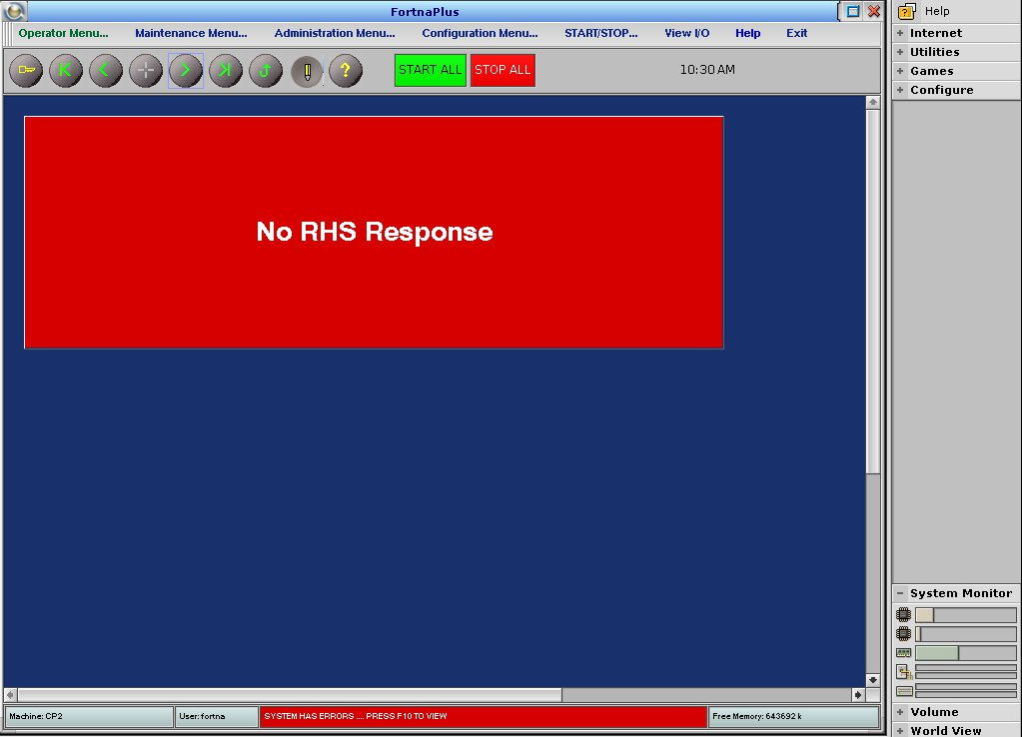
The response from CommCore for an RHS message contains status information in the sStatus field and, if an error has occurred, in the sStatusMsg field. If sStatus is anything other than OKAY or Okay, sStatusMsg will contain a description of the error. This error description can be displayed on the AC main screen.
It is assumed you know how to create IO and conveyor parts. You can find instructions on how to do that in the FPC documents section on Redmine.

Configuration – Memory Bits
Two memory bits are needed for the two types of RHS failures that can occur. Create the parts and name them as follows:
- RHSFail – This output will be fired when an RHS response indicates a host communications failure
- RHSNoResponse – This output will be fired when no RHS replies are received within the configured period of time.

Configuration – On-Screen Part
A part is needed for an on-screen text field that will display the messages. Refer to the document on On-Screen Buttons available on Redmine to create a part named RHSFail-Text. Select ESTOP in the Default Colors field. Position and size the part on the conveyor display so it will be easy to see.

Configuration – Errors Table
Create two records in table Errors:
ErrorName | Owner | Description | TrigIO
RHS Fail | <AC Name> | <from RHS msg> | RHSFail
RHS No Response | <AC Name> | No RHS Response | RHSNoResponse
continued:
ScrnIO | Suggestion | Severity | Alarm_Category
RHSFail-Text | <select desired> | <select desired> | Comm
RHSFail-Text | <select desired> | <select desired> | Comm
Leave the default values in all other fields.

Configuration – SrtHrtBeat Table
Create one record in table SrtHrtBeat:
Name | EnableFlag | ControlMachine | MsgMenu
CommHB | Y | <AC Name> | MsgGP4

HrtMsgTable | HBTimeIntrvl | HBMsgIntrvl | MsgErrTime
MsgGP4 | 10 | 10 | 30

CommErrSignal | CommErrACTION | CommErrBIT | HostErrSignal
RHS No Response | FIRE | 0 | HBFail

HostErrACTION | HostErrBIT | ErrorsRecord
FIRE | 0 | RHS Fail

RHS Processing Explanation
Using the above configuration, when an error is reported in the RHS message response, these actions will occur:
- The content of the sStatusMsg field will be copied to Errors_Description in the RHS Fail record.
- SrtHrtBeat_pHostAlrmState will be set to 1.
- SrtHrtBeat_HostErrSignal will be fired. This output will trigger the AC’s error-handling subsystem to create an entry in the Current_Errors table, which has been configured to display the error’s Description field on screen.
Using the above configuration, when no response is received to an RHS message for 30 seconds (MsgErrTime), these actions will occur:
- SrtHrtBeat_pCommAlrmState will be set to 1.
- SrtHrtBeat_CommErrSignal will be fired. This output will trigger the AC’s error-handling subsystem to create an entry in the Current_Errors table with a description of “No RHS Response” (from Errors_Description for the “RHS No Response” record).

On-Screen Status Examples
The following screen shots show on-screen error messages for the above configuration:
No message is displayed if communications are good:
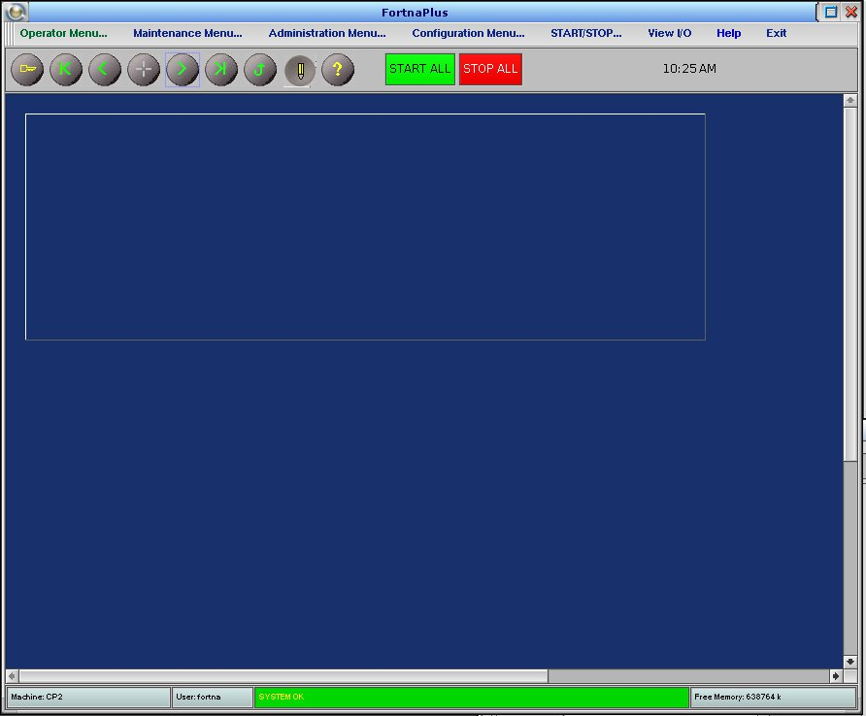

If an RHS message is received with sStatusMsg of “COMM TIMEOUT”:
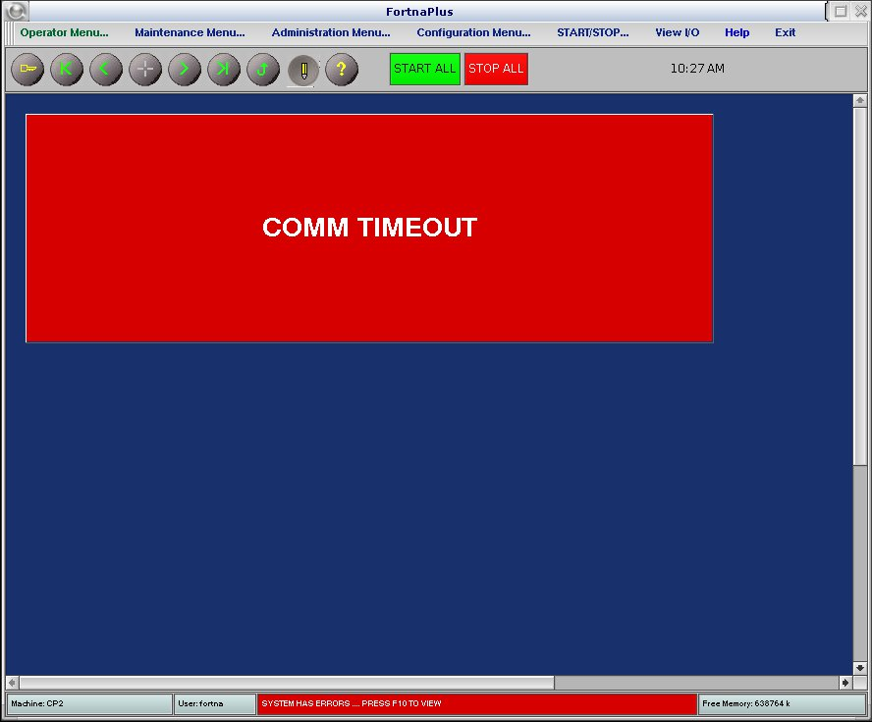

If an RHS message is received with sStatusMsg of “SOCKET DISCONNECT”:
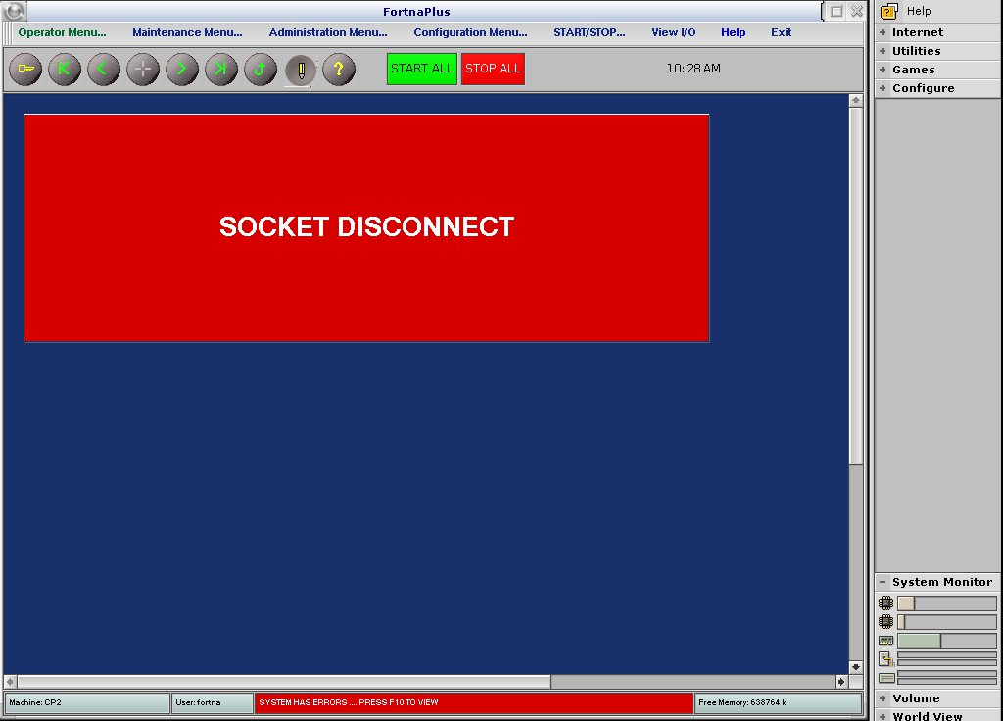

If no RHS message response is received:


